Stakeholder Engagement Results
February 9th, 2023

ABOUT THE COLLABORATIVE
The Wyoming Collaborative for Healthy Soils (WCHS) is a stakeholder engagement effort aimed at engaging the broad agricultural community to identify ways to support producers in the voluntary adoption of soil health practices on croplands and grazing lands. It is currently funded by the University of Wyoming. Started by Dr. Jay Norton in Winter 2022, WCHS is now led by Dr. Liana Boggs Lynch at the University of Wyoming with the support of Ground Up Consulting. This work will culminate in the development of a roadmap to advance and incentivize the voluntary soil health practices in June 2023. As a member of the agricultural community, we hope that you will participate.

Guided by a diverse Coordination Team, WCHS is gaining input from the agricultural community in various ways to develop the soil health roadmap. This includes a) listening sessions; b) surveys for producers and agricultural professionals; and c) working groups. The three working groups are: 1) Stakeholder Engagement; 2) Science and Practice of Soil Health; and 3) Education. Larger “Full Collaborative Meetings” are held regularly to engage and solicit feedback from those unable to otherwise participate.

WCHS’s core principles include being producer-centered; science/evidence-based;; participatory, collaborative and transparent; and action-oriented. The group commits to only pursue solutions that are voluntary/incentive-based (no new mandates). All are welcome to join the Coordination Team and to participate in working groups.

Find out more about WCHS at www.groundupconsulting.us/wchs.
Part 1: Who did we hear from?
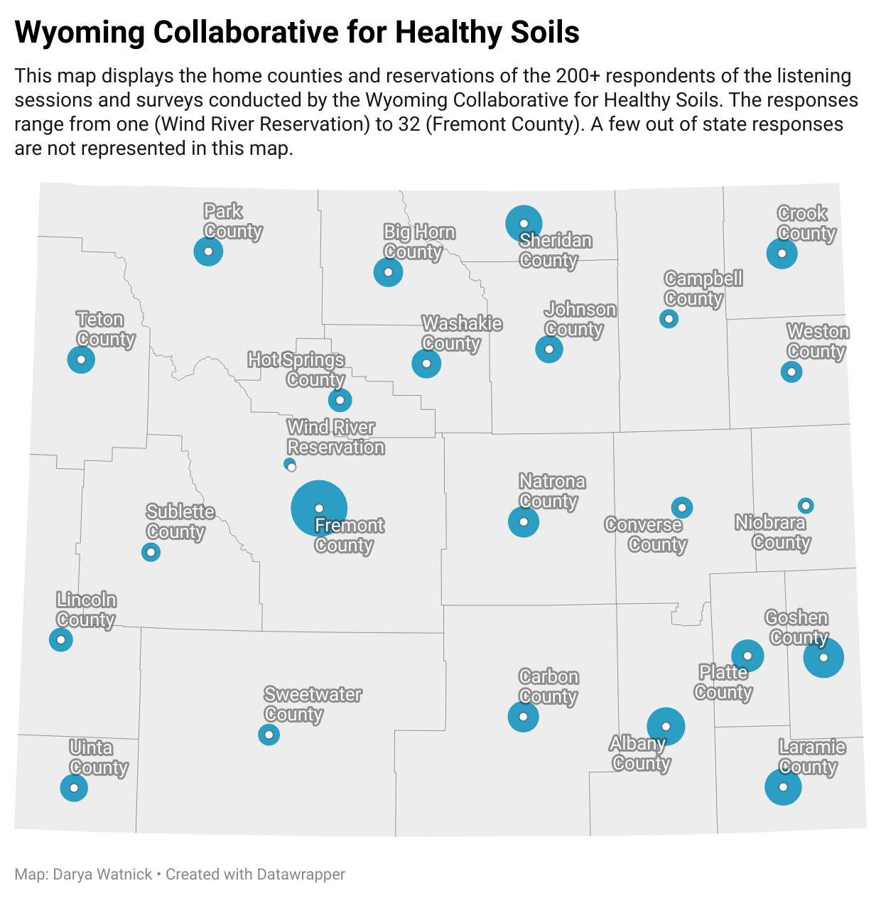
In total, the Wyoming Collaborative for Healthy Soils heard from 234 people across every county in the state. WCHS held eight listening sessions; five of these were at Area Meetings held by the WACD; one was at a WY Food Coalition virtual meeting, one was held at the Natural Resource Rendezvous, and one was a virtual WCHS listening session. In total, 157 people participated in WCHS listening sessions. The Stakeholder Engagement Working Group also designed two surveys for producers and ag professionals that were open from September through December, 2022. The producer survey had 57 respondents; the ag professional survey had 20 respondents.

What county are you located in?
(combined results of listening sessions and surveys; n=234)

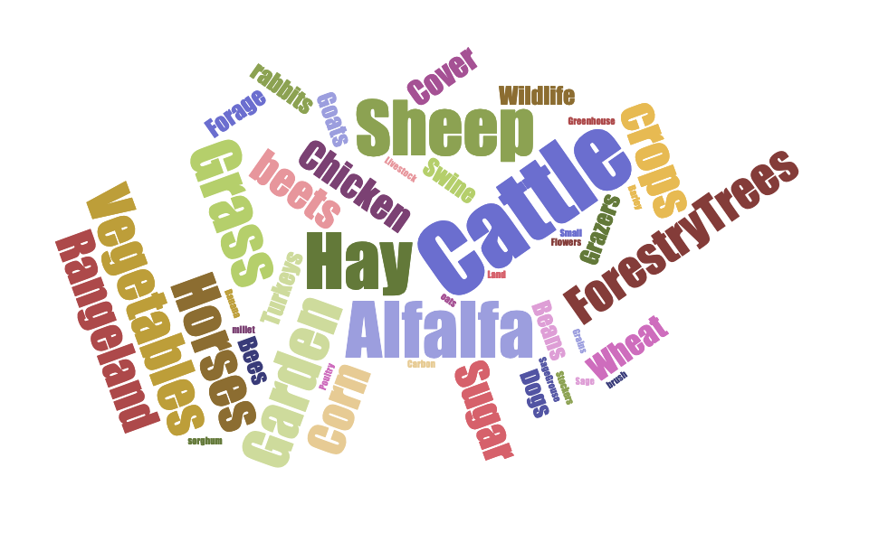
What type of livestock or crops do you raise or consult on?
(combined results; n=234; size of the word indicates the relative number of responses)

What best describes you?
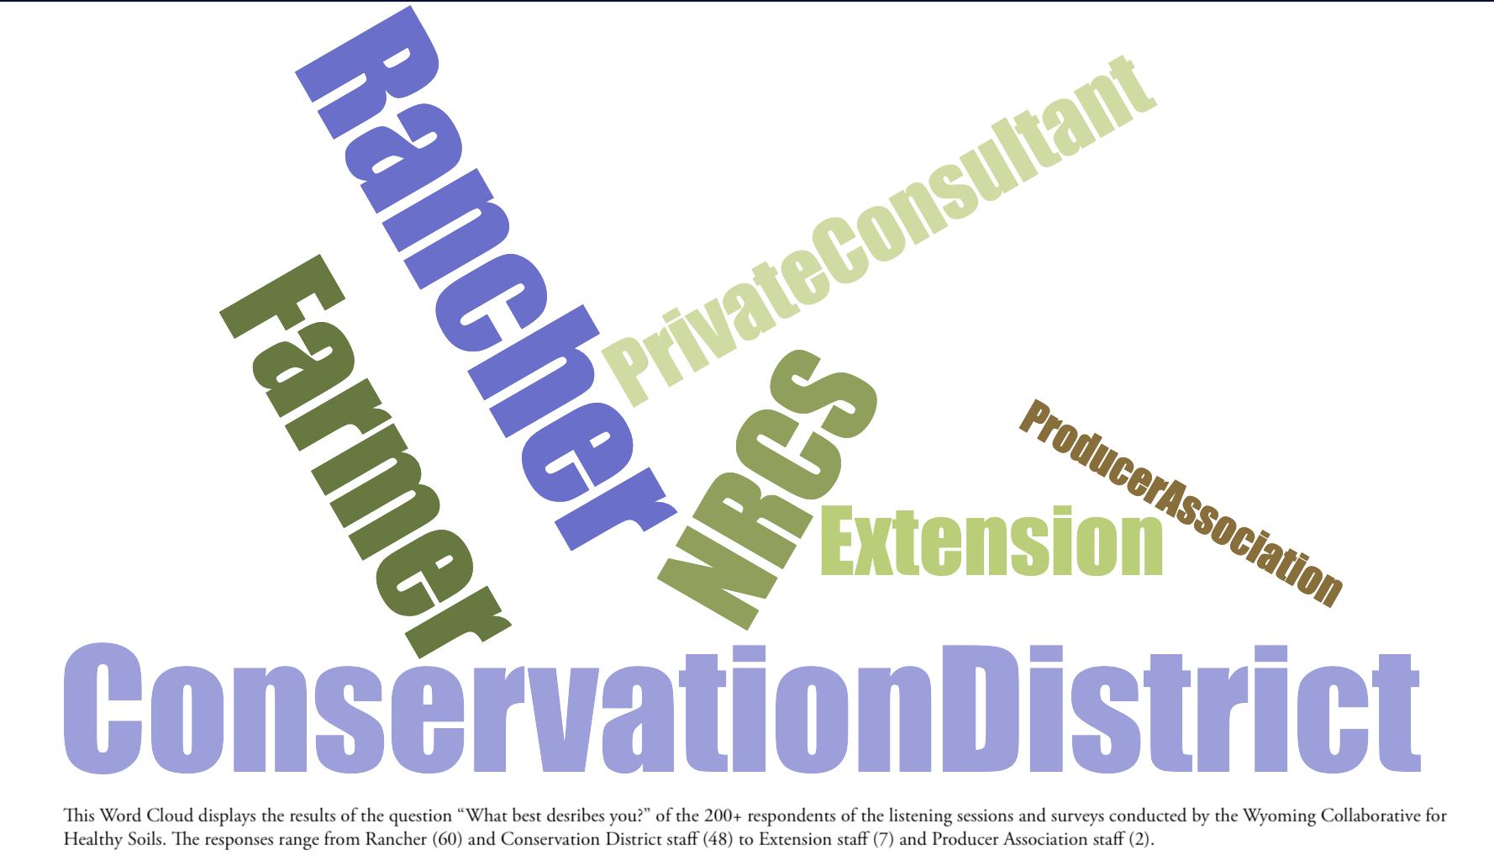
(combined results; n=234; size of the word indicates the relative number of responses)

Part 2: What is currently being done for soil health?
This section examines what soil health practices are currently in use; producer interest in making improvements to soil quality or health; and the reasons for adopting new or additional soil health.

What practices are you or your customers/members currently using or have used in the past to improve your soil health?
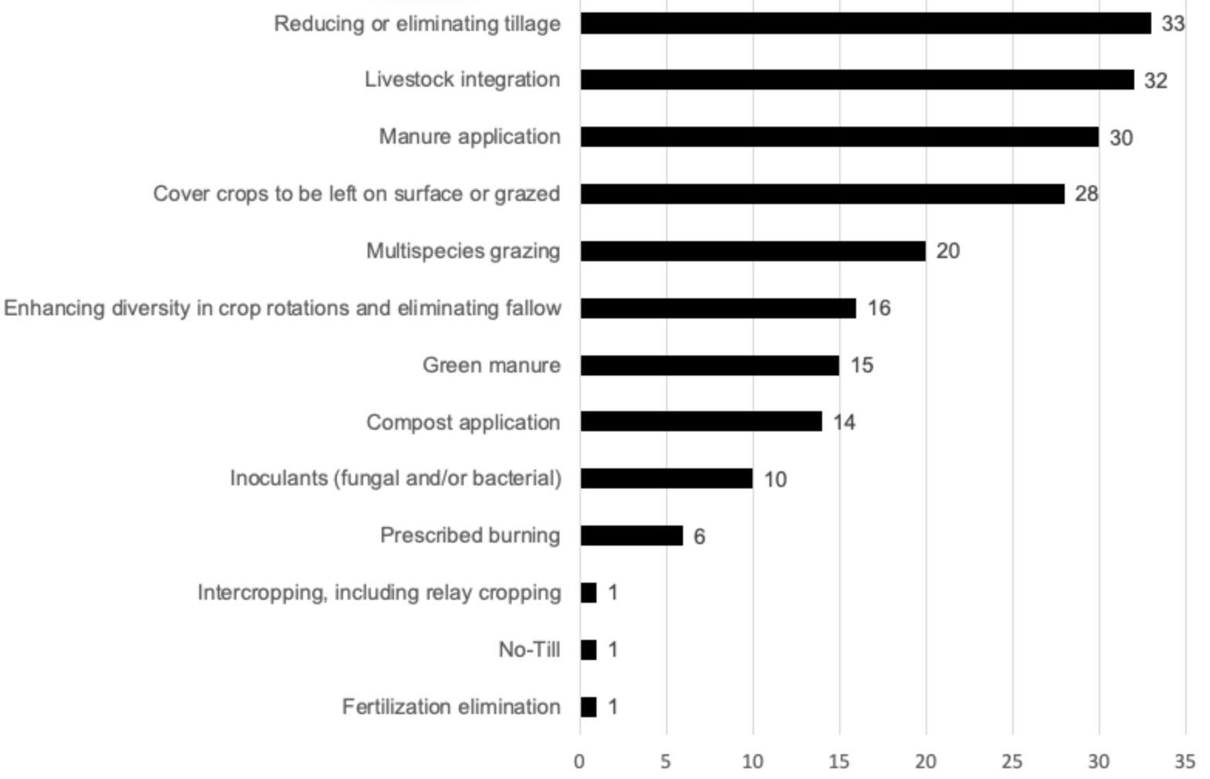
(combined surveys from producers and ag professionals; n=77)

Rate your interest in improving soil quality or health
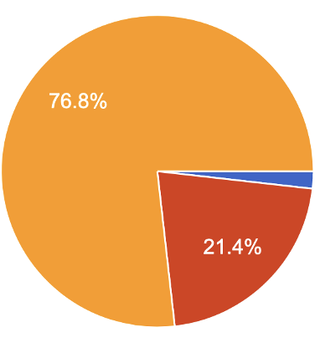

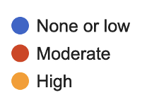

Producers (survey; n=57) Ag professionals (survey; n=20)
What are the most important reasons for soil health on your operation?
(producer survey; n=57)

Responses | Low | Moderate | High
Reduced input costs | 20.00% | 29.23% | 50.77%
Wind and water erosion | 15.00% | 35.00% | 50.00%
Water infiltration | 13.11% | 31.15% | 55.74%
Water holding capacity / drought resilience | 7.94% | 30.16% | 61.90%
Soil organic matter level | 6.67% | 21.67% | 71.67%
Soil tilth | 4.55% | 27.27% | 68.18%
Compaction | 12.07% | 29.31% | 58.62%
Soil crusting | 15.79% | 40.35% | 43.86%
Alkali soils | 24.07% | 35.19% | 40.74%
Nutrient cycling | 6.78% | 28.81% | 64.41%
Plant health | 11.11% | 20.63% | 68.25%
Pest and disease management | 13.33% | 28.89% | 57.78%

Why do your customers/members want to improve their soil health?
(ag professional survey; n=20)

Responses | Low | Moderate | High
Reduced input costs | 0.00% | 35.29% | 64.71%
Wind and water erosion | 11.76% | 35.29% | 52.94%
Water infiltration | 8.33% | 16.67% | 75.00%
Water holding capacity / drought resilience | 6.25% | 12.50% | 81.25%
Soil organic matter level | 11.11% | 33.33% | 55.56%
Soil tilth | 21.43% | 28.57% | 50.00%
Compaction | 35.71% | 14.29% | 50.00%
Soil crusting | 33.33% | 25.00% | 41.67%
Alkali soils | 42.86% | 28.57% | 28.57%
Nutrient cycling | 6.25% | 50.00% | 43.75%
Plant health | 5.88% | 29.41% | 64.71%
Pest and disease management | 18.75% | 37.50% | 43.75%

Part 3: What would producers like to be doing for soil health?
This section reports on what else producers would like to be doing for soil health; the barriers producers face in adopting new or additional practices; and the barriers ag professionals face to meeting their customers/members needs.

What else would you or your customers/members like to be doing on your operations for soil health?
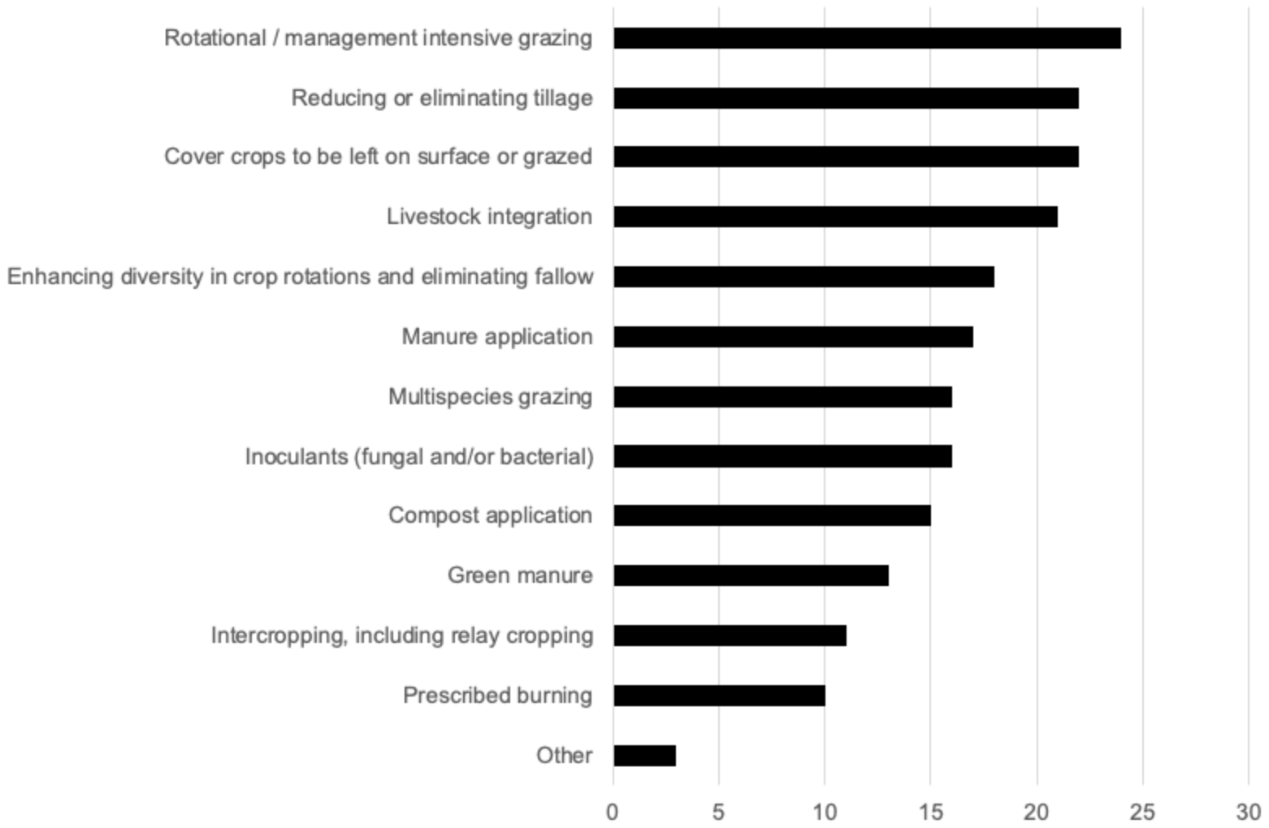
(combined surveys; n=77)

What are the most significant barriers that you or producers in your area face in improving soil health?
(producer survey; n=57)

Response | Low | Moderate | High
Cost of soil improving practices | 3.39% | 32.20% | 64.41%
Lack of information | 14.81% | 42.59% | 42.59%
Lack of technical assistance | 8.62% | 48.28% | 43.10%
Low residue crops | 8.33% | 50.00% | 41.67%
Managing high levels of crop residue | 33.33% | 35.56% | 31.11%
Sandy Soils | 32.00% | 34.00% | 34.00%
Required tillage | 28.85% | 44.23% | 26.92%
Livestock rotational restrictions | 37.78% | 28.89% | 33.33%
Lack of markets | 40.00% | 30.00% | 30.00%
Crop insurance restrictions | 38.78% | 26.53% | 34.69%
Access to land | 36.17% | 36.17% | 27.66%
Access to specialized equipment | 25.64% | 38.46% | 35.90%

What are the barriers to implementing new or additional soil health practices in your area?
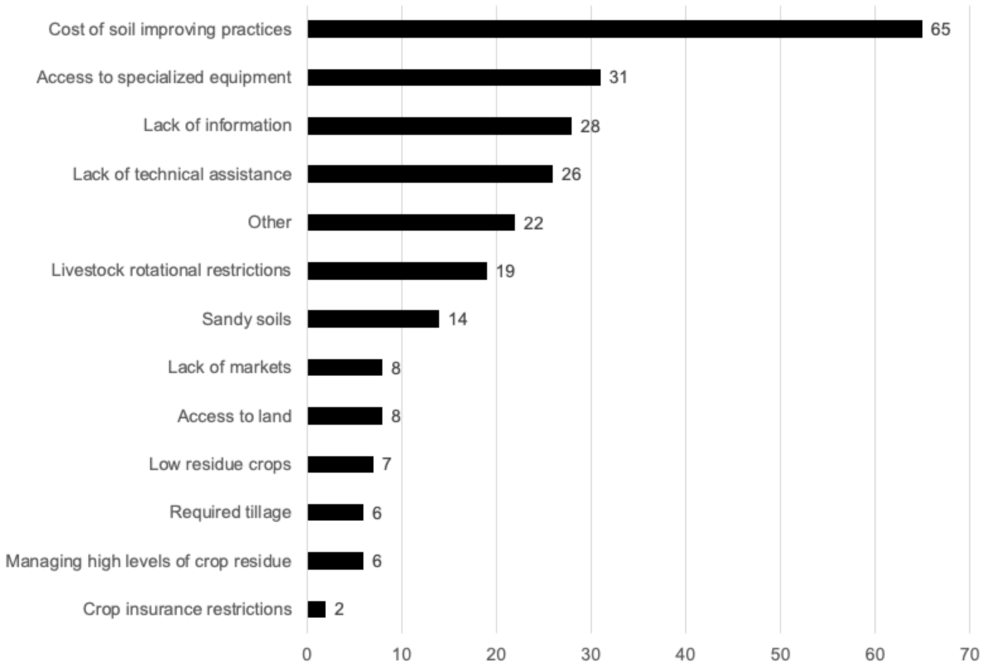
(listening sessions; n=157)

Ag Professional Barriers:

For Ag Professionals: What are the biggest barriers to meeting your customers'/members' needs around soil health?
(ag professional survey, n=20)

Response | Low | Moderate | High
Staffing for soil health related activities | 33.33% | 38.89% | 27.78%
Funding for your organization for soil health related activities | 27.78% | 33.33% | 38.89%
Lack of information | 35.29% | 47.06% | 17.65%
Lack of funding for producers (cost share) | 33.33% | 33.33% | 33.33%
Lack of technical assistance | 35.29% | 41.18% | 23.53%
Lack of educational materials for producers | 17.65% | 52.94% | 29.41%
Lack of soil health testing and monitoring | 20.00% | 20.00% | 60.00%

Part 4: What is needed to support the voluntary adoption of new soil health practices?

What mechanisms would support producers in your area in achieving their soil health goals?
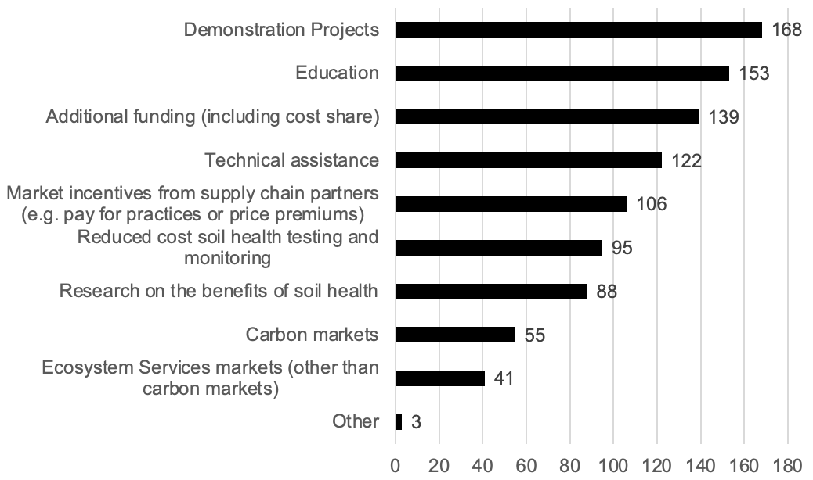
(combined results; n=234)

What additional educational resources are needed to support producers
in your area?
(listening sessions; n=157)
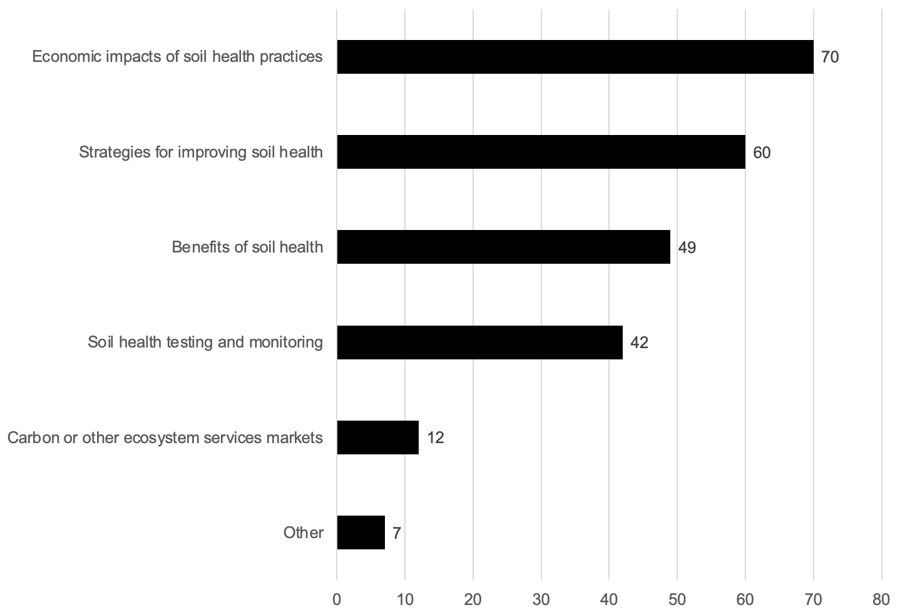

Rate the need for research or additional information on the following topics.
(producer survey; n=57)

Response | Low | Moderate | High
Economic impacts of soil health practices | 8.20% | 27.87% | 63.93%
Soil health testing and monitoring | 1.61% | 46.77% | 51.61%
Benefits of soil health | 15.00% | 36.67% | 48.33%
Strategies for improving soil health | 6.90% | 18.97% | 74.14%
Carbon or other ecosystem services markets | 17.86% | 44.64% | 37.50%

For Ag Professionals: What additional educational resources do you need to support your customers/members in the voluntary adoption of soil improving practices?
(ag professional survey; n=20)

Response | Low | Moderate | High
Economic impacts of soil health practices | 0.00% | 23.53% | 76.47%
Soil health testing and  monitoring | 11.76% | 17.65% | 70.59%
Benefits of soil health | 18.75% | 25.00% | 56.25%
Strategies for improving soil health | 11.76% | 17.65% | 70.59%
Carbon or other ecosystem services markets | 35.29% | 23.53% | 41.18%

Part 5: Notable quotes and common themes
This section includes notable quotes and common themes by topic. These were collected through five one-on-one interviews conducted with farmers and ranchers in Albany, Platte and Carbon counties; from notes that were taken (with permission) at all eight listening sessions; and from additional comments collected from survey respondents. Quotes have been edited for clarity.

Please provide additional information that you feel we should know or that you would like to tell us about soil health in your region.
(selected results from combined surveys)

On producer interest in soil health:
- “Soil health is strong and growing in Crook County”
- “There is very little regard for soil health in our area. Great people but change is hard.”

On the barriers to soil health:
- “After 14 yrs of rotational grazing I find that it is my skills and knowledge that are the weakest link”
- “I believe the greatest challenge for improving soil health in my area is lack of rainfall. So much of the soil health regenerative measures include cover crops and intercropping which needs adequate rainfall to establish those practices. My main priority is trying to become much more efficient in how I utilize the moisture I do receive.”
- “Distance from markets and lack of storage and equipment for harvesting are the most significant factors.”
- “(One major challenge is) how to incorporate cover crops when you have limited labor for field work.”

On potential new ideas and opportunities:
- ““(It could make) a HUGE impact to offset the cost for the first three years for producers as they make the switch to soil health practices”
- “Research (is needed) to show the benefit in soil health and economics….More land managers need to be involved in this.”
- “How can NRCS and UW work together to best benefit producers?”
- “The best opportunity to improve soil health in Albany County is maximizing the benefits of prescribed grazing.”

Common themes from producer interviews
(one-on-one producer interviews; n=5)

Theme | Notes from combined interviews
Definition of soil health | Respondents identified the definition of soil health as a key question for the group to take on. “There is a need to set baselines and identify parameters specifically for WY.”  Other questions include: What does soil health mean across a diversity of soil types? On rangelands specifically?
Difficulty of change | Multiple respondents commented on the difficulty of change. Many producers are doing what has been done in WY for years and years. It could be that degradation is happening too slowly for some to realize. “It is a brittle environment, one that is easy to mess up in and has a long recovery period.” Many producers are afraid to mess up what they currently have.
Economics and soil health | Cost and time were identified as some of the biggest barriers. “Soil health is not like putting a chemical on and getting an immediate result; it requires 5+ years and results are slow.” Projects have to pay for themselves. It takes a long time to recoup the cost of capital improvement. Covering expenses for experimenting would allow for more experimentation.
Potential new ideas and opportunities | Interviewees expressed interest in peer-to-peer learning; demonstration sites; a list of producers in WY who are doing soil health improvements; regionally-specific economic case studies. New collaborations were also encouraged. ”(We need to) think outside of what we are typically involved in.”

Appendix: An online appendix of additional maps, tables and graphs can be found at https://docs.google.com/document/d/14Ck2C7aZOh4AjnYLLwAic-akvQ3Xu3txMYFXX2wiQ9A/edit?usp=sharing.

The Coordination Team includes agricultural producers, University of Wyoming soil scientists, Wyoming Association of Conservation Districts, Wyoming Stock Growers Association, Extension specialists, Central Wyoming College, and others.
Full data available upon request. Please reach out to max@groundupconsulting.us with inquiries.

